Dear Conference Organizing Committee,

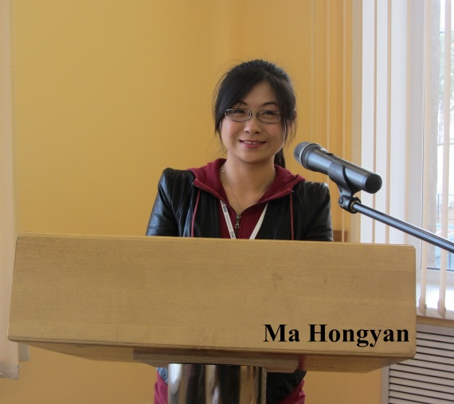
I am writing this letter to thank you for you warm hospitality accorded to me during TranSoilCold2015 in your beautiful city. With kind personal regards.

Please find my photo in the attached text.

Thank you very much.

Hongyan Ma

