Dear Alexander Isakov,

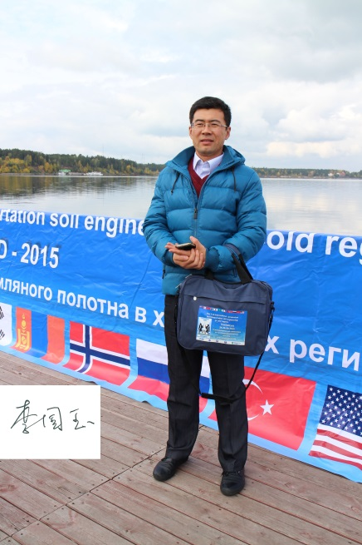
Thanks for your help in Russia and great efforts for holding this great conference. This is my picture as you requested when Prof. Liu Jiankun told us.

Best regards

Guoyu Li

