Dear friends,

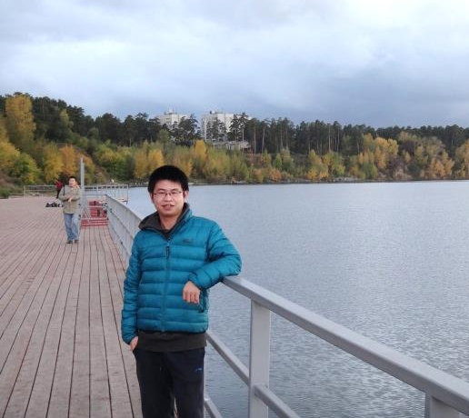
Thank you very much for warm entertaining! It is a really unforgetable trip to Novosbirsk, involving the conference and the parties!

I feel Novosbirsk is a fantasitc place, I am so exciting to enjoy a week in Novosbirsk!

The attachment is my photo. Appreciate warm reception again!

Best regards!

Yuan Chang

2015/10/3

