Dear Prof. Isakov,

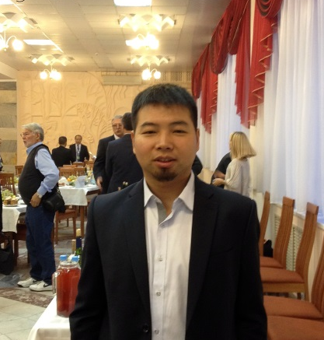
Thanks very much for your host.
I enjoyed the warm workshop and had an excellent experience in Novosibirsk.
My signed photo is attached with this email.
I hope to see your people in 2017.

Best Wishes
Xu LI

