Dear Dr. Aleksey L. Manakov, Alexander L. Isakov, Valery S. Vorobjev, Vladimir P. Nehoroshkov, and other local organizing committee and volunteers,

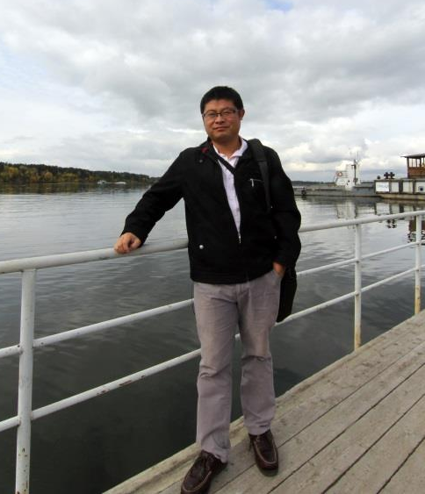
I am Yupeng SHEN from Beijing Jiaotong University.

It is wonderful conference and thank you for your hard work! Everyone gave me the warmth and generous that it is my favorite time out of China.

I sincere invite you to visit Beijing to express Chinese hospitableness.

Yupeng Shen
Department of Highway and Railway Engineering
School of Civil Engineering
Beijing Jiaotong University

