Dear Dr. Aleksey L. Manakov,

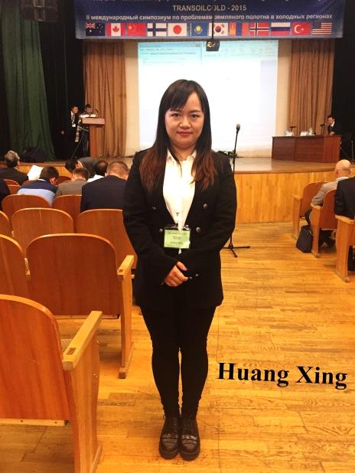
Thank you for inviting me to attend the 2nd International Symposium on Transportation Soil Engineering in Cold Regions, and thanks all the teachers and volunteers of your university. It was my pleasure to attend this conference, and I think your university held a successful conference. I think you have done enough work for every part of conference and I learnt so many things from this conference and from the spirits of your people. I want to visit and study at your university in the future, if I have chance. There are three photos of mine in attachment, and now I am working at College of Architecture and Urban-Rural Planning, Sichuan Agricultural University, and which is in Chengdu. Please visit our university if you have opportunity. And thanks again. Best regards!

Sincerely yours

Huang Xing
