Thank all the organizers for organizing the Symposium so good.
Thank all the volunteers for helping us well!
Thank all the experts and scholars for sharing the knowledge with us!
Siberian State University of Railway Engineering is so beautiful!
Novosibirsk is so beautiful!

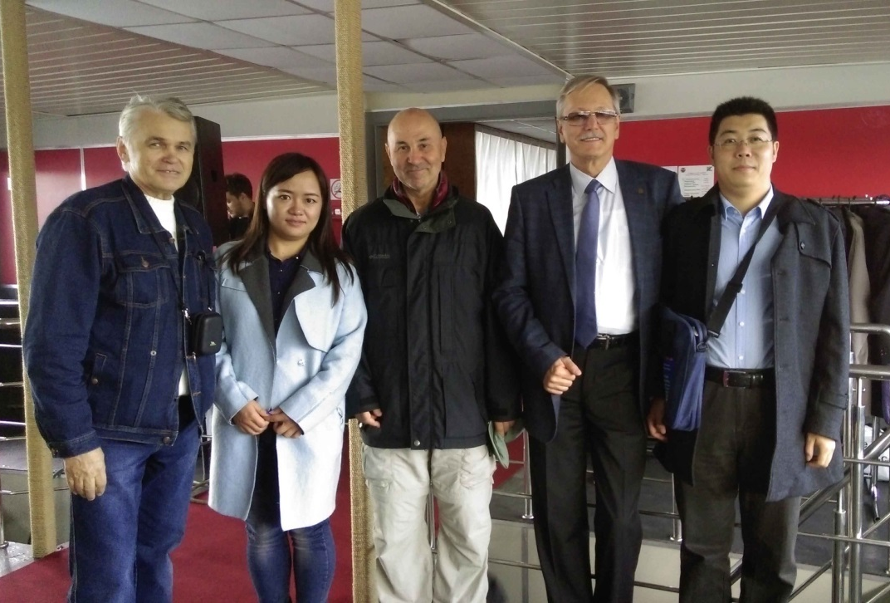
Qianmi Yu

Qianmi Yu,
Beijing Jiaotong University, 2015-9-28

