Dear Conference Organizing Committee,

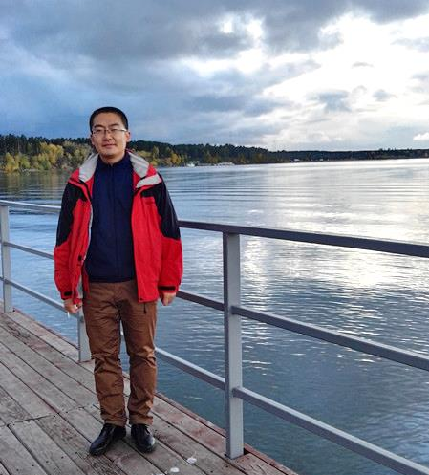
Many thanks for your great contribution for this conference. The 5 days at Novosibirsk is a deep and happy memory for me to recall. I am extremely looking forward for the next conference in Xining, China. See you guys there!

In the attachment is my personal photo.

Best Regards,
Xiaoliang
CAREERI, Chinese Academy of Sciences

